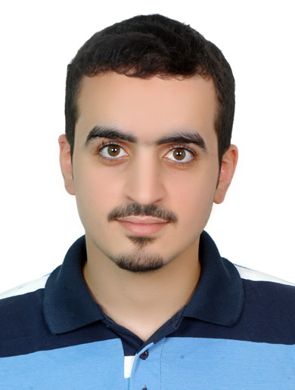 **Curriculum Vitae**

Personal Information

|  |  |  |  |
| --- | --- | --- | --- |
| **Full Name** | Abdulla Ali Salman | **Date of Birth** | July 3rd,1995 |
| **Place of Birth** | Jidhafs | **Marital Status** | Married |
| **Nationality** | Bahraini | **Religion** | Muslim |
| **English Skills** | Good | **Computer Skills** | Good |
| **Drive License** | Driving licence private | **CPR No.** | 950700819 |

Education

|  |  |  |  |  |
| --- | --- | --- | --- | --- |
| **School** | **Degree** | **City/**  **Country** | **Major** | **Graduation Year** |
| Sheikh Abdul Aziz Bin Moh'd Al Khalifa | Secondary | Adliya | Literary | 2013 |

Work Experience

|  |
| --- |
| **4 years** working at Al-Helli supermarket as **Cashier**  Since **March 10th, 2015**. |

**Contact:**

**Mobile Number : 33715153**

**Address** : **Building No.** : 2127 **Road** : 844 **Block** : 708 Salmabad